Pitch Perfect
Congratulations! You’ve made it through a cramped & sweaty coach journey down from Manchester and have finally arrived at Glastonbury. You’ve got the whole festival ahead of you, excited doesn’t even come close.
Queues conquered and wristbands on, you and your friends prepare for challenge number one – pitching your tent.
As thousands descend upon the farm, you’re unlikely to find a spacious clearing so the trick is to work out if you can squeeze your tent into a more unusual space.
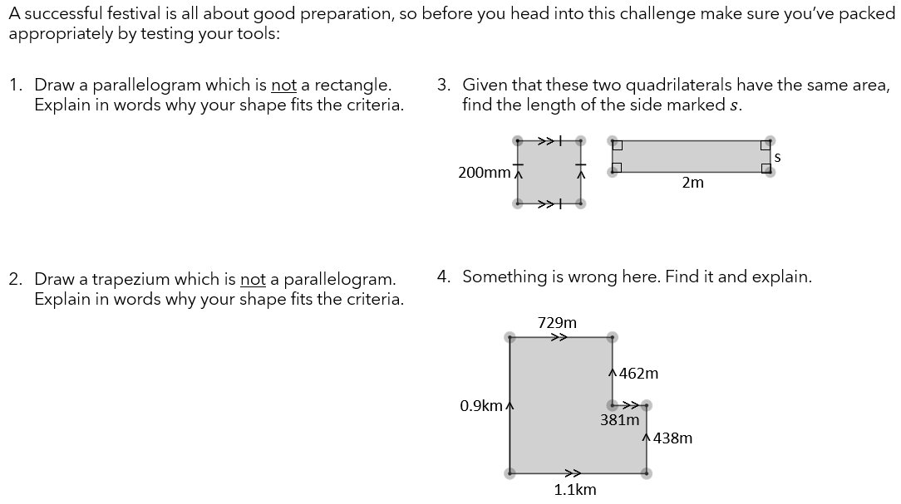
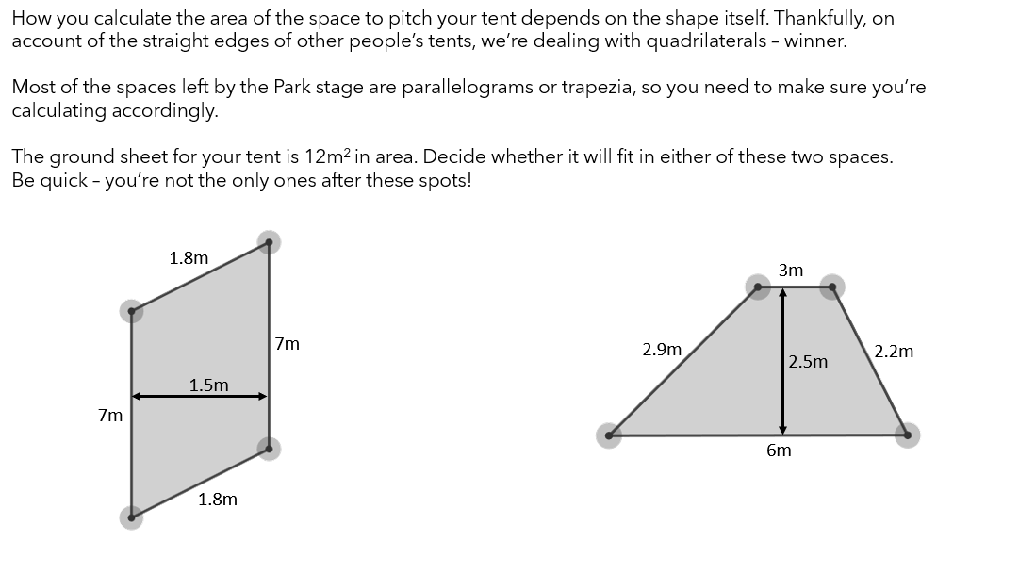
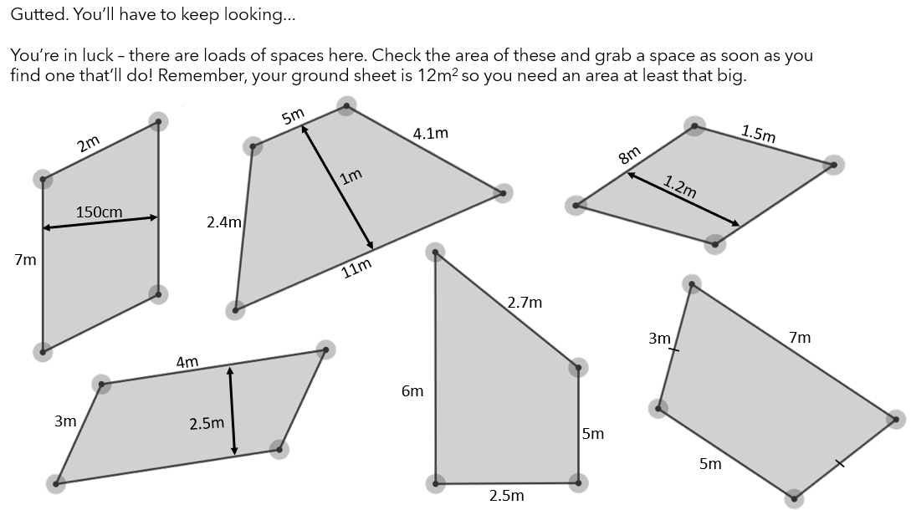

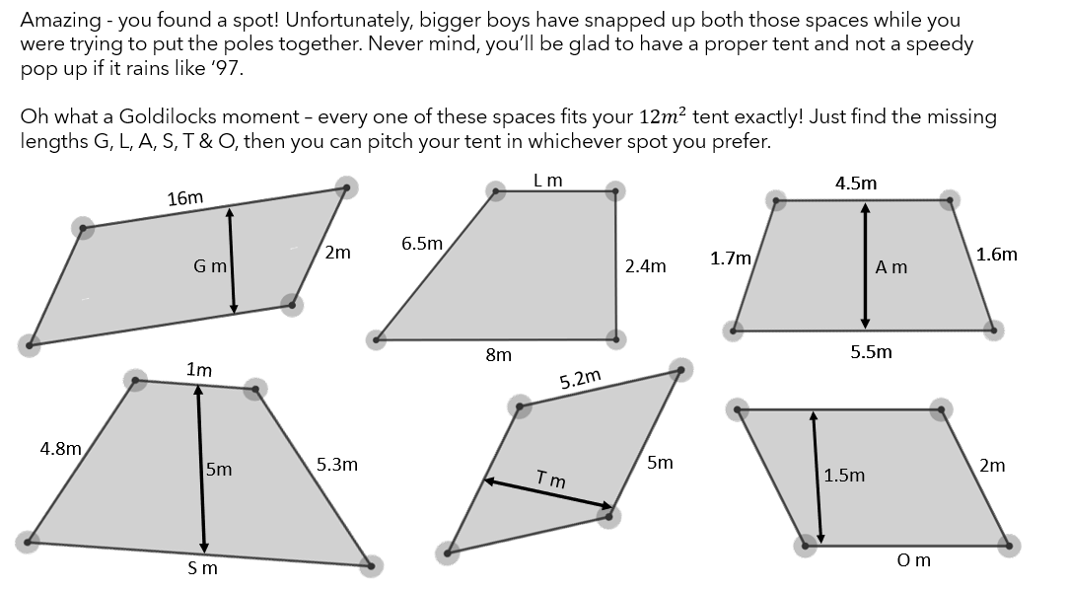

Solutions

