Packed with Goodness
Your tent is pitched, your Glasto home is almost ready. Before you head up Glastonbury hill to take in the enormous wonder of it all and wallow in the mounting anticipation, you’ve got to conquer the lowlight of any getaway: unpacking.
Don’t be down though, proper packing makes for a well-supplied weekend so dragging your rucksack for miles from the coach gate will be worth it when Sunday comes and you’re the cleanest queen in the campsite, wanting for nothing.
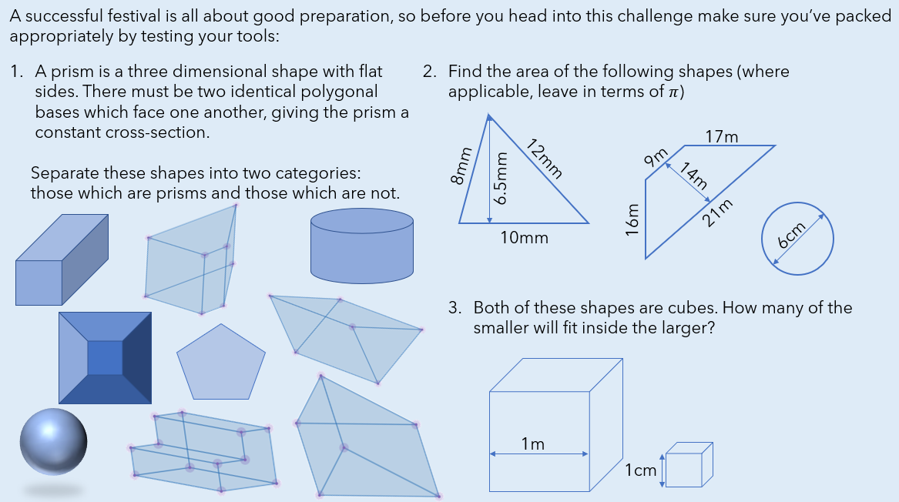
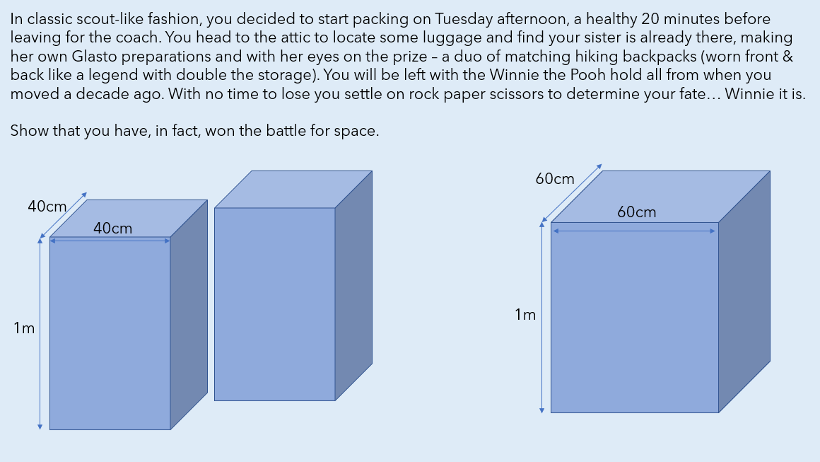
Yes, this isn’t your first rodeo, you’ve got baby wipes and toilet roll for days as well as the potential for outfit changes at Gaga level frequency. Now it’s just a matter of fitting all that clobber in the tent…
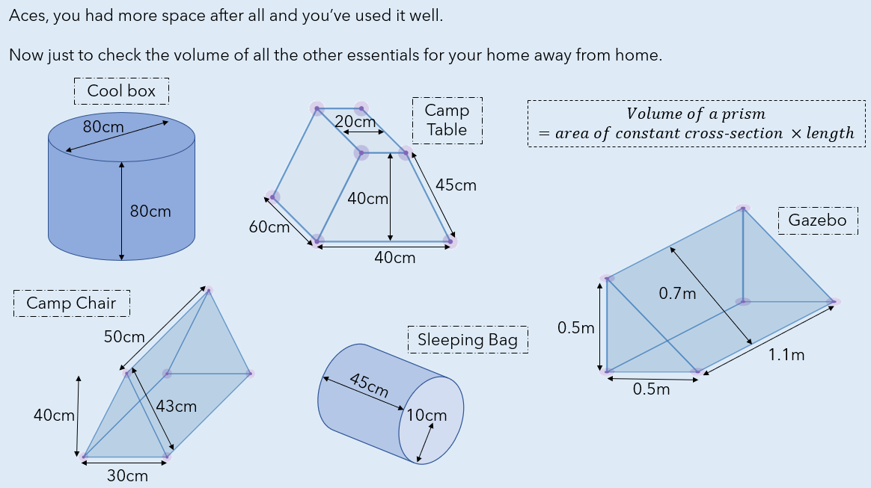

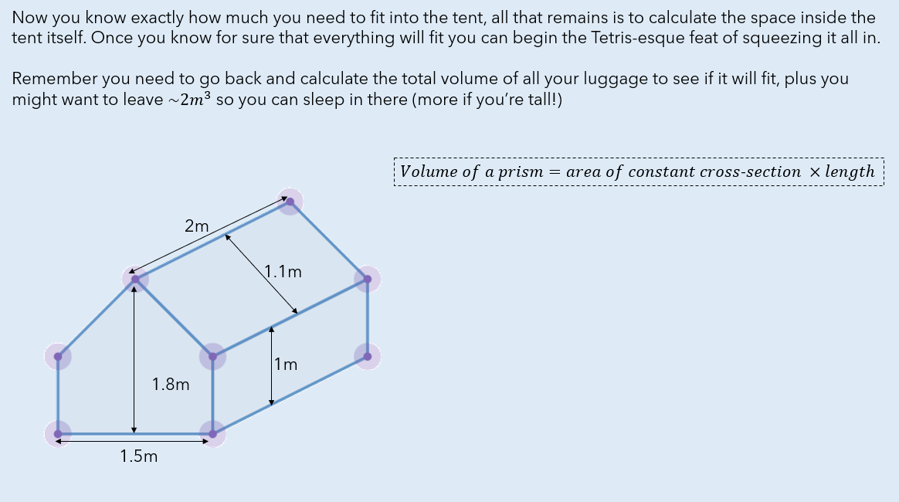

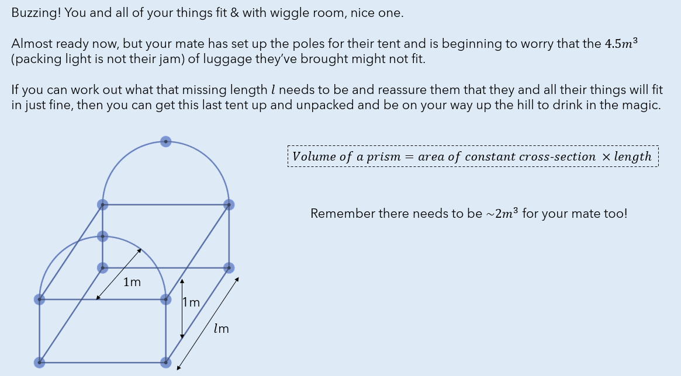

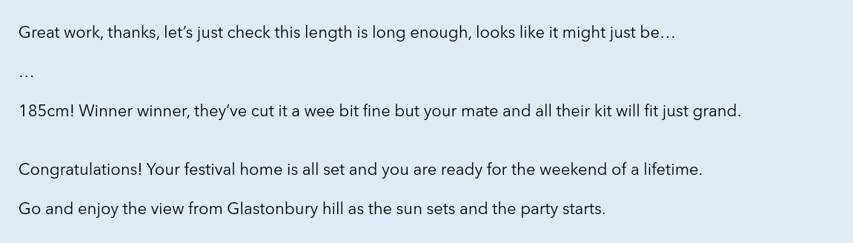

Solutions
